More Two-Body System Problems
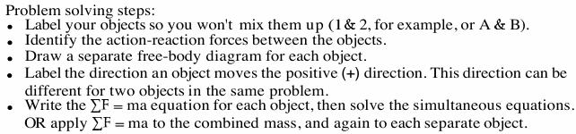
Newton’s Second Law for a System:
Net External Force = Total Mass x Acceleration of the system

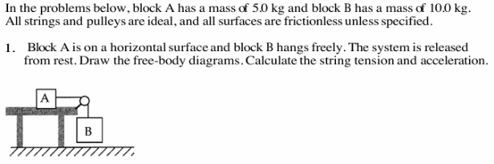

2.
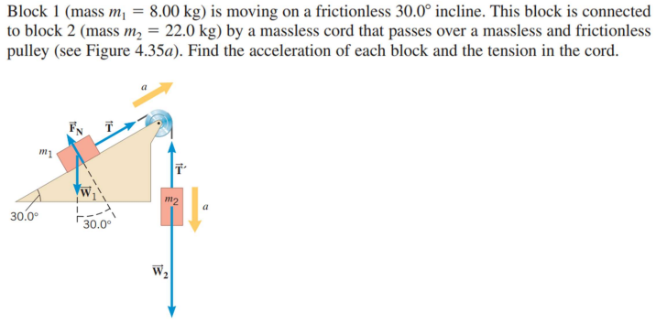

3.
